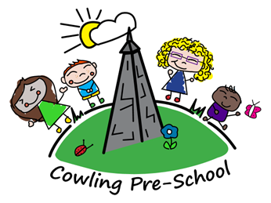

Summer term 1 newsletter

Firstly, a warm welcome back to everybody, we hope you have all had a wonderful easter break, we have a very busy term ahead of us! We will be preparing some of our older children for the transition to school, whilst welcoming some new children into our pre-school. We will still continue to have our normal weekly activities going on such as Makaton on a Tuesday morning and Kanga on a Thursday, the library will continue to be accessible to all in a morning.

As the warmer weather approaches, we will be spending more time outside, please ensure your child is dressed appropriately for the weather, we will use a standard sun cream, which we be Asda’s own brand if you do not wish for your child to use this cream, please let us know. Please can all children, bring in a named sun hat that will stay at Pre-School for the whole summer term.

Over the next couple of weeks, we will be working on independence, for example handling own needs, putting on own coats, independent toileting etc, to build children’s independence and confidence before school. We will also be focussing on letters, numbers, colours and shapes; this will be done in small groups to allow children to maintain focus.

We will also be focussing on the Queens Jubilee, we will be talking about our Monarchy and why this is important, we will be producing lots of artwork for this, ready for the Jubilee celebrations.

We will also spend some time focussing on holidays and summer Themes, as some children may be going on their holidays, if you are going on holiday, please bring us some pictures in from your holidays, or any previous holidays we will use these on a display.

Please Keep an eye out for children’s observations on Tapestry, it would be lovely to have some more interaction from parents on Tapestry as this Journal will be available for you to download and keep when your child leaves Pre-school. All communication is now done through Class dojo so please continue checking this App.

As always, we have an open-door policy, so if you have any queries, questions or concerns please do come in and speak to us.

Here are some key dates of some of the exciting thigs happening this term!

Key dates:

Pre-school will close for half term on Friday 27th May and reopen on Monday 6th June.

Saturday 4th June: Queens Jubilee, we are hoping to have a table in the Jubilee celebration in the village, we will be using this event to fund raise for Preschool, therefore we will be holding a cake sale and face painting. We would be very grateful if parents can donate some bakes for us to sell, or if any parents would be willing to come along and help out? If any parents have any suggestions on what else we could do to raise funds please let us know your ideas.

Friday 17th June 10am: Father’s Day morning (Sporting events and bacon butties)

Wednesday 29th June/ Tuesday 5th July/Wednesday 6th July: (as yet we don’t have a specific date until Eureka get back to us, but these are the dates we have requested, as soon as we have this information it will be shared) This trip is exclusively for school leavers only as a treat before they leave school, unfortunately Pre school will be closed on this day for any other children as all staff will be on the trip.

Friday 15th July: Graduation Day for School leavers, this will be in the afternoon so Pre School will close at 12pm on this day. Graduation will start at 12.30 in The Bay Horse Beer Garden.

Friday 22nd July: pre school will close for the summer and we will return on Tuesday 6th September