Autumn Term 2nd Half

We have started this half term with a flying start, with lots of big plans for Christmas, it is all feeling very magical!

All the new children have settled in beautifully, and have now all been assigned a key worker, if you are still unsure who your childs key worker is please ask a member of staff.

Our two new key workers Jess & Jessica have settled in really well to the role, and are really enjoying being part of our pre school. We also have a new student Lucy who is joining us from Craven College, Lucy will be with us on a Wednesday & Friday.

Some more Baby news! (don’t worry the rest of the staff will no longerbe sitting on chairs!) Becki is also expecting a baby! Becki’s baby is due in April.

We are obviously very happy for Becki and her family.

Over the course of December we will have lots of exciting activities taking place, we have our exciting trip coming up, a Christmas performance down at St Andrews church. We have also enquired with messy play in regards to a messy session before Christmas, we will share this date with you when we have one.

We will also be putting a post box outside of pre school, for children who want to bring in any Christmas cards for their friends.

As the winter months approach us can all parents ensure children come to pre- school in an appropriate coat for the weather and bring a pair of wellies, we already have waterproof trousers at pre- school. This means we can still take children out for walks.

We have now got a library card for the Library in Crosshills, we will take the childen on a bus, we have already done the first trip and it was so lovely! The library welcomed us and offered to run a story session every week, unfortunately due to the opening times Wednesday will be the only available day we can go.

In January we will be holding parent consultation days, these will take place over the course of two weeks, there will be an opportunity to book appointments with your childs key worker throughout the course of a chosen day, more details will be shared soon.

Also in January Liz Ensor from Toddle & Sign will be delivering weekly Makaton sessions on a Tuesday, this is to assist children who may have communication delays but also a great tool for children who can communicate freely, to build skills to assist communication amongst peers.

We have had a few comments from parents in regards to paint on clothing, whilst we get this can be frustrating, we would like to remind you that one of the reasons we introduced the uniforms was to protect childrens personal clothing from getting ruined, we would also remind parents if you do not have a uniform please do not send children in their best clothes. Whilst children are at pre-school they are encouraged to participate in all activities including messy play, painting is a free flowing activity and sometimes stopping childrens creativity to add aprons can be restricting and often stops creativity and play.

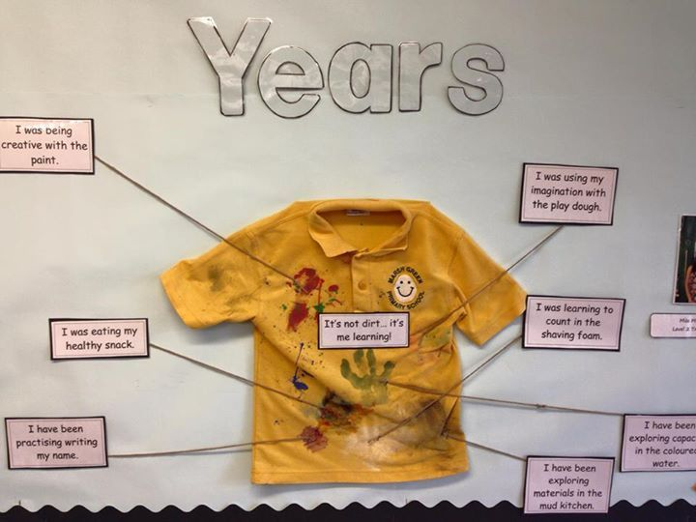

Our pre-school finds itself in a very vunerable position, our treasurer has resigned from pre school with immediate affect, therefore we currently have no one in this position. This role is a named role and in order for pre school to still function this position must be filled! We have a three month grace period to fill this position, however if we do not fill this position in three months the pre school will close! If you know anyone who can help us out please, please please let us know.

Pre-school will close on Friday 17th December, at 2pm this allows staff time to deep clean the room ready for January, we will reopen on Wednesday 5th January 2022